SILVERHILL PRIMARY SCHOOL



SEND Information
April 2026

Review date | By whom | Summary of changes made | Date ratified by governors/trustees | Date implemented
24/04/27 | CW

Contents
Special Educational Needs and Disability (SEND) ..….……………………………………………….…………..3
Contact ………………………………………………………………………………………………………………………………..3
Complaints …………………………………………………………………………………………………………………………..3
Local Authority Support ……………………………………………………………………………………………………….3
SEND Admissions ………………………………………………………………………………………………………………...4
What information does the SEND Code of Practice state that schools must provide? ………..4
Who can I talk to in this school about my child's difficulties with learning or behaviour? …..4
What are the different types of support available for children with SEND? ………………………..5
How can I let the school know that I am concerned about my child's progress? …………………7
How will the school let me know if they have any concerns about my child at school? ….…..7
How is extra support allocated the children? …………………………………………………………..………...8
Which other services provide support for children with SEND at Silverhill Primary? …………..8
How are the staff in school supported to work with children with SEND? ………………..….…….9
How will the teaching be adapted for my child with SEND? ………………………………………………10
What support do we have for you as a parent of a child with SEND? ……………………………….10
How is Silverhill Primary School accessible to children with SEND? ………………………………….10
How will we measure the progress and attainment of your child at school? …………………...11
How will we support your child in transition periods ………………………………………….……..…….12
(such as moving between year groups?)
What steps have been taken to prevent children with ……………..…………………….………..……..13
SEND from being treated less favourably than other children?
How will we support your child's emotional and social development? …………………..………..13

Special Educational Needs and Disability (SEND)
At some time in their school career, your child may need some help which is different to that required by most of the other children in their class. Examples of this are:
There is a bereavement in the family and a child needs specialised help to cope with their feelings.
A child is making little progress in reading and needs a specialised programme and some 1-1 support.
The behaviour of a child becomes particularly difficult to manage and parents and school work together to support the child.
A child wears a hearing aid and his seating position in the classroom must be carefully considered in every lesson.
All of the above and many more come under the umbrella term of ‘Special Educational Needs and Disability’. At Silverhill Primary School we endeavour to provide effective support for these children and their parents.

Contact
Our Special Educational Needs Co-ordinator (SENCO) is Mrs Wheeler and they can be contacted via the school office by phoning 01332 511138 or by email at senco@silverhill.derby.sch.uk

Complaints
If you have any complaints regarding the SEND support your child is receiving please see our complaints policy.

Local Authority Support
Please visit the Derby City Council SEND website at:
https://www.derby.gov.uk/education-and-learning/derbys-send-local-offer/

SEND Admissions
All admissions for the school, including children who may have a SEND, are dealt with by the Admissions team at Derby City Council. Here is a link to their website which shows the details of how to apply for a place at the school:
https://www.derby.gov.uk/education-and-learning/schools-and-colleges/school-admissions/primary-school-admissions/
A copy of the school SEND Policy can be found on the Policies page of our website which is in the Statutory Information tab.

What information does the SEND Code of Practice state that schools must provide?
Schools have additional duties under the Special Educational Needs and Disability Regulation 2014. Schools must publish more detailed information about their arrangements for identifying, assessing and making provision for pupils with SEND.
The information must also include information about the arrangements for the admission of disabled pupils, the steps taken to prevent disabled pupils from being treated less favourably than other pupils, the facilities provided to assist access for disabled pupils and the schools’ accessibility plans. The school-specific information should relate to the schools’ arrangements for providing a graduated response to children’s SEN. It should elaborate on the information provided at a local authority wide level in the Local Offer.

Who can I talk to in this school about my child's difficulties with learning or behaviour?
The Class Teacher
Responsible for
- Checking on the progress of your child and identifying, planning and delivering any additional help your child may need (this could be targeted work or additional support) and letting the Special Education Needs/Disabilities Co-ordinator (SENCo) know as necessary.
- Writing Pupil Progress targets/Individual Education Plans (IEP), and sharing and reviewing these with parents once each term, as well as planning for the next term. Specific teaching and learning for your child as identified on the class provision map.
- Ensuring that the school's SEND Policy is followed in their classroom and for all the pupils they teach with any SEND.

The SENCo, Mrs C. Wheeler
Responsible for
- Developing and reviewing the school's SEND policy.
- Co-ordinating all the support for children with special educational needs or disabilities (SEND)
- Liaising with all the other people who may be coming in to school to help support your child's learning, e.g. Speech and Language Therapy, Educational Psychology.
- Updating the school's SEND list (a system for ensuring that all the SEND needs of pupils in this school are known), and making sure that records of your child's progress and needs are kept securely. Providing specialist support for teachers and support staff in the school, so that they can help children with SEND in the school to achieve the best progress possible

Ensuring that you are
- involved in supporting your child's learning
- kept informed about the support your child is getting
- involved in reviewing how they are doing
The Head Teacher, Mr S. Burley
Responsible for
- The day-to-day management of all aspects of the school; this includes the support for children with SEND.
- The Head teacher will give responsibility to the SENCo and class teachers, but is still responsible for ensuring that your child's needs are met.
- The Head teacher ensures that the Governing Body is kept up to date about issues relating to SEND.
The School Governors
Responsible for
- Ensuring that the necessary support is given for any child with SEND who attends the school.
School contact number: 01332 511138

What are the different types of support available for children with SEND?
Class teacher input, via targeted classroom teaching and Quality First Practice.
For your child this would mean
- That the teacher has the highest possible expectations for your child and all pupils in their class.
- That all teaching is built on what your child already knows, can do and can understand.
- That different ways of teaching are in place, so that your child is fully involved in learning in class. This may involve things like using more practical learning.
- That specific strategies are in place to support your child to learn.
- Your child's teacher will have carefully checked on your child's progress and will have decided that your child has a gap or gaps in their understanding/learning and needs some extra support to help them make the best possible progress. In certain cases, an Individual Education Plan will be implemented.
Specific interventions
These can be
- Run in the classroom or a group room.
- Run by a teacher or a teaching assistant (TA).
- Individual or small group
- Specialist interventions run by outside agencies, e.g. Speech and Language therapy
Classification of need
A pupil who has been identified by the SENCo/class teacher as needing a significant level of extra support in school is said to be at the SEND support level.
Level 1
The teacher has had a discussion with the SENCo and parents to highlight concerns. Extra support is put in place within the classroom. At this stage, monitoring will take place at regular intervals. If there is no significant improvement, the child will be moved to level 2, and a formal Individual Education Plan put in place.
Level 2
An Individual Education Plan (IEP) is devised for the child, which is shared with parents. This plan is reviewed with parents on a termly basis. Parental permission will be sought if any referrals to specialists are required. A higher level of support in the classroom will be implemented. A child may receive a diagnosis at this stage but still remain at Level 2, depending on support required.
Level 3
The child requires a significant level of support in the classroom and may require an EHCP (Education, Health, Care Plan issued by the Local Education Authority) to formalise their support.
Specialists to whom the school regularly refers include;
- Educational Psychologist
- Community Paediatrician
- Speech Therapist
- Specialist Advisory Teachers
- Lead Behavioural Nurse (ADHD specialist)
- CAMHS (Child and Adult Mental Health Services) or Compass Changing Lives
- Occupational and Physiotherapy services

Education Health Care Plan
The school (or parents/Guardians, through the local authority website) can request that Local Authority Services carry out a statutory assessment of your child's needs. This is a legal process which sets out the amount of support that will be provided for your child.
After the request has been made to the 'Panel of Professionals' (with detailed information about your child, including some from you), they will decide whether they think your child's needs (as described in the paperwork provided), seem complex enough to need a statutory assessment. If this is the case, they will ask you and all professionals involved with your child to write a report outlining your child's needs. If they do not think your child needs this, they will ask the school to continue with the current level of support.
After the reports have all been sent in, the Panel of Professionals will decide if your child's needs are severe, complex and lifelong. If this is the case, they will write an Education Health Care Plan (EHCP). If this is not the case, they will ask the school to continue with the current level of support.
The EHCP will outline the support your child will receive and how the support should be used, including what strategies must be put in place. It will also have long and short-term goals for your child.

How can I let the school know that I am concerned about my child's progress?
If you have concerns about your child's progress, you should speak to your child's class teacher initially.
If you continue to be concerned that your child is not making progress, you may speak to
SENCo – Mrs C. Wheeler
Head Teacher – Mr K. Savage

How will the school let me know if they have any concerns about my child at school?
If the school has concerns about your child's learning or behavior, the class teacher and/or SENCo will set up a meeting to discuss this with you in more detail and to
- listen to any concerns you may have.
- Plan any additional support your child may need.
- Discuss with you any referrals to outside professionals to support your child.
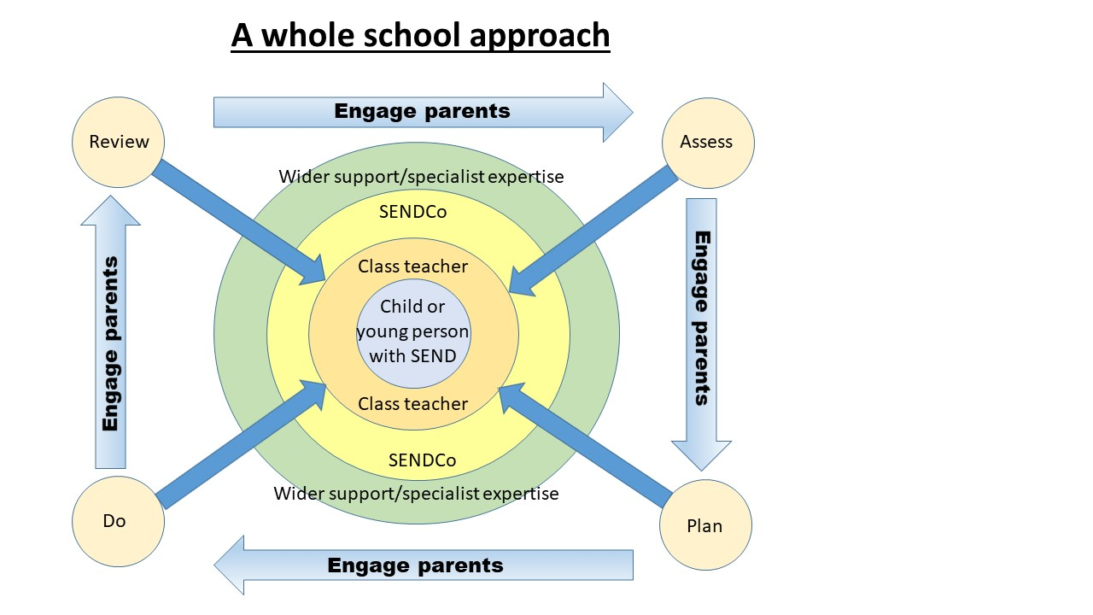
How is extra support allocated to the children?
The school budget, received from Derby City LA, includes money for supporting children with SEND.
The Head Teacher decides on the deployment of resources for Special Educational Needs and Disabilities, in consultation with the school governors on the basis of needs in the school.
The Head Teacher and the SENCo discuss all the information they have about SEND in the school, including:
- a review of children on the SEND list,
- children needing extra support,
- children who have been identified as not making as much progress as would be expected.
From this information, they decide what resources/training and support is required and ensures that staff are deployed effectively to meet the needs of the children.

Which other services provide support for children with SEND at Silverhill Primary?

School provision
- Teaching Assistants with either individual children or small groups
- A variety of interventions such as Rapid Writing, Read it, Write It, Speed Up Handwriting, Precision Teaching, Group Guided Reading, Comprehension skills, Numicon Programme, NESSY (spelling and reading), TT Rockstars (timestables), ELSA Support, Lego therapy, Life Skills etc (subject to change according to needs).
- The Learning Mentor offers ELSA support for children with emotional and social development needs, anger management, concentration and with specific issues such as bereavement
- Various assessments carried out by Teaching Assistants and SENCo

Local Authority Provision delivered in school
- Autism Outreach Service
- Educational Psychology Service
- Sensory Service for children with visual or hearing needs
- Parent Partnership Service

Health Provision delivered in school
- School Nurse
- Community Paediatrician
- Occupational Therapy
- Physiotherapy
- CAMHs
- Speech and Language Therapy

How are the staff in school supported to work with children with SEND?
The SENCo's job is to support the class teacher in planning for children with SEND.
- The school provides support to enable all staff to improve the teaching and learning of children, including those with SEND. This includes whole staff training on specific aspects of SEND.
- Individual teachers and support staff attend training courses run by outside agencies that are relevant to the needs of specific children in their class.

How will the teaching be adapted for my child with SEND?

Class teachers plan lessons according to the specific needs of all groups of children in their class and will ensure that your child's needs are met.
Teaching assistants, under the direction of the class teacher, will support children who have learning or behavioural needs in a variety of ways.
Specific resources and strategies will be used to support your child individually and in groups.
Planning and teaching will be adapted, on a daily basis if required, to meet your child's learning needs.

What support do we have for you as a parent of a child with SEND?
The class teacher should always be spoken to in the first instance and an appointment can be made by telephoning the school office to discuss your child's progress or any concerns you may have, and to share information about what is working well at home and school, so that similar strategies can be used.
- The Inclusion Manager/SENCo is available to meet with you to discuss your child's progress or any concerns/worries you may have (telephone the school office for an appointment).
- All information from outside professionals will be passed onto you, either via a report sent directly from the professional, or during a meeting.
- Personal progress targets (IEPs) will be reviewed with your involvement every term.
- Homework will be adjusted as needed to your child's individual requirements.

How is Silverhill Primary School accessible to children with SEND?

- The school is fully compliant with DDA requirements.
- The school is on a single-level with easy access and double doors.
- The front desk is accessible to wheel-chair users.
- There is a toilet for the disabled.
- We ensure wherever possible that equipment used is accessible to all children regardless of their needs.
- There is a breakfast club and afterschool club, providing wrap-around care, which is available to most children with SEND.
- Extra-curricular activities and residential trips are suitable for most children with SEND.

How will we measure the progress and attainment of your child at school?

- Your child's progress will be continually monitored by his/her class teacher.
- His/her progress will be reviewed formally with the Headteacher and SENCo every term in reading, writing and numeracy.
- At the end of Year 6, all children are required to be formally assessed using Standard Assessment Tests (SATS). This is something the government requires all schools to do and the results are published nationally. Some children with SEND are eligible for additional time during the Year 6 SATS and/or may be supported by an adult reader or prompt.
- Where necessary, children will have an Individual Education Plan (IEP) plan based on targets set by outside agencies specific to their needs. Targets will be set that are designed to accelerate learning and close the gap. Progress against these targets will be reviewed regularly and updated at a meeting involving parents each term.
- The progress of children with an EHC Plan will be formally reviewed at an Annual Review with all adults involved with the child's education.
- The SENCo will also check that your child is making good progress within any individual work and in any group that they take part in.
- Regular book scrutinies and lesson observations will be carried out by the SENCo and other members of the Senior Leadership Team to ensure that the needs of all children are met and that the quality of teaching and learning is high.
- Some children will also be assessed via the school’s own system called ‘S-Levels’ (Silverhill Levels), this enables the school to monitor small steps of progress where children are working below the standard expected for their age (this is at the class teacher’s discretion only).

How will we support your child in transition periods (such as moving between year groups?)

The Governing body believes that the admissions criteria should not discriminate against pupils with Special Educational Needs or Disabilities and has due regard for the practice advocated in the Code of Practice 2015.
We recognise that transitions can be difficult for a child with SEN, and we take steps to ensure that any transition is a smooth as possible.
If your child is joining us from another school:
- The SENCo will visit pre-schools with the Foundation Stage Leader when appropriate.
- If your child would be helped by a book/passport to support them in understanding moving on, then one will be made for them.
- All children will be able to visit our school and stay for a taster session.
- In exceptional circumstances, an enhanced transition may also take place.
If your child is moving to another school:
- We will contact the school SENCo and ensure they know about any special arrangements or support that needs to be made for your child.
- We will make sure that all records about your child are passed on as soon as possible.
When moving classes in school:
- Information will be passed on to the new class teacher in advance and in most cases a planning meeting will take place with the new teacher. Individual Education Plans will be shared with the new teacher.
- Enhanced transitions may be arranged in certain circumstances
In Year 6:
- The SENCo will discuss the specific needs of your child with the SENCo of the child’s secondary school. For children with an Education Health Care Plan, a transition review meeting, to which you will be invited, will take place with the SENCo from the new school.
- Your child will participate in focused learning relating to aspects of transition, to support their understanding of the changes ahead.
- Where necessary, your child will have an enhanced transition process, where your child will visit their new school on several occasions, and in some cases staff from the new school will visit your child in this school.
What steps have been taken to prevent children with SEND from being treated less favourably than other children?
Statement of Inclusion
The following statement refers to all Silverhill Primary School policies:
Silverhill Primary School will not treat a disabled child less favourably for reasons related to their disability. Every effort will be made to ensure that disabled pupils are not placed at a substantial disadvantage in comparison with their non-disabled peers without justification.

How will we support your child's emotional and social development?
We recognise that some children have extra emotional and social needs that need to be developed and nurtured. These needs can manifest themselves in a number of ways, including behavioural difficulties, anxiousness, and being uncommunicative.
All classes follow a structured PSHE (Personal, Social, Health and Emotional education) curriculum to support this development. However, for those children who find aspects of this difficult we offer:
- One to one counseling sessions with the Learning Mentor
- Nurture, anger management and social communication skills groups
- Lunchtime support through planned activities and groups.
- Access to a therapy dog
If your child continues to needs extra support, it may be applicable to access further help through the EHA (Early Help Assessment) process. In this case, parents will be invited to a meeting to discuss this referral.

